**Task 3 : cat commands**

1. **Create 3 files namely umuzi.md, recruits.md and cohort.md.**

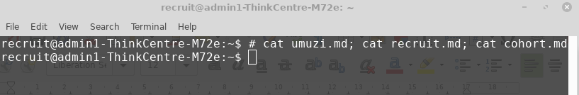

1. **Fill all 3 files with contents of your choice. Maybe some nice poems about you MUB experience.**
2. 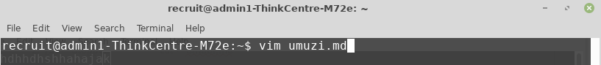

open umuzi.md in vim.

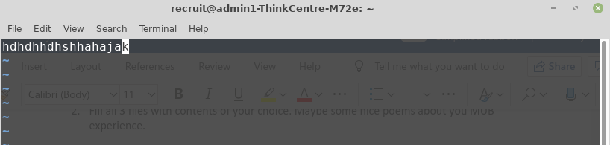

Text inside umuzi.md.

1. 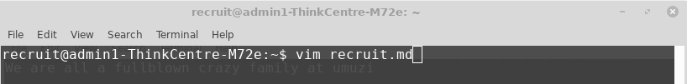

Open recruit.md in vim.

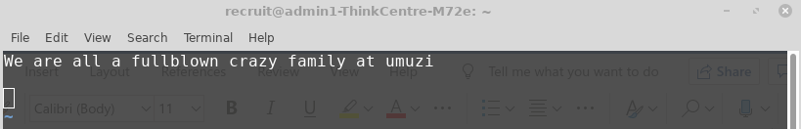

Text inside recruit.md.

1. 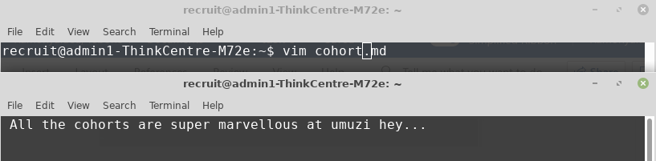

Open cohort.md in vim.

Then add some text inside cohort.md.

1. **Write a script that concatenates the content of umuzi.md, recruit.md, cohort.md and displays the result on the screen.**

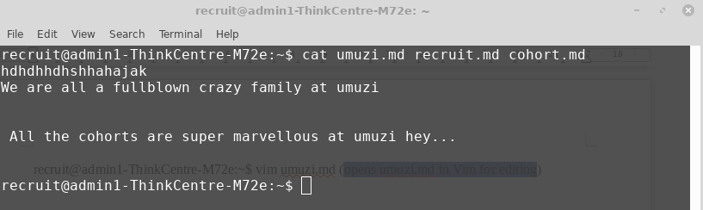

1. **Write a script that takes the content of umuzi.md, cohort.md and recruits.md to print/store the output into a new file named summary.md.**

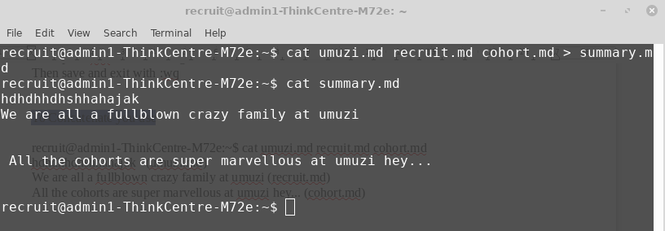

1. **use the command line to append the words “The End” to summary.md. Be careful not to overwrite the exiting contend**

